**FUNDAMENTALS OF DATA ANALYTICS WITH TABLEAU**

Project Title:

Estimation of Business Expenses

NAAN MUDHALVAN PROJECT ID:

NM2023TMID27528

**TEAM MEMBERS:**

K. Rajalakshmi (Team leader)

G. Dhivya Dharshini

M. Dhivalini

M. Gayathri

M. Susila



PG AND RESEARCH DEPARTMENT OF PHYSICS

**RAJA DORAISINGAM GOVERNMENT ARTS AND SCIENCE COLLEGE**

**SIVAGANGAI-630 561**

**Estimation of Business Expenses**

# INTRODUCTION

* 1. Overview
* This involves estimating all the expenses required to start and operate the business, such as equipment, rent, inventory, and marketing.
* By calculating these costs upfront business owners can better plan their budget and avoid unexpected expenses.
  1. Purpose
* Expenses are deducted from revenue to arrive at profits.
* These expenses will be subtracted from business revenue to show a company’s net profit or loss and taxable income.

# Problem Definition & Design Thinking

* 1. Empathy map

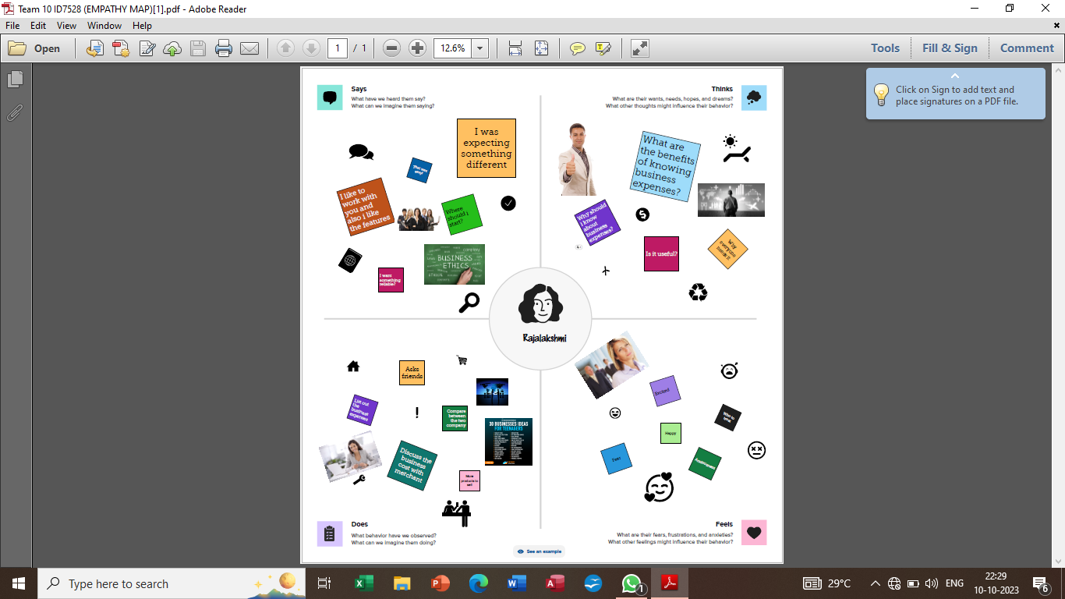

* First we make a empathy map for a group idea.
* To create a empathy we go to mural website and logic with email account and search the templates that you wanted to create.
  1. Ideation & Brainstorming Map

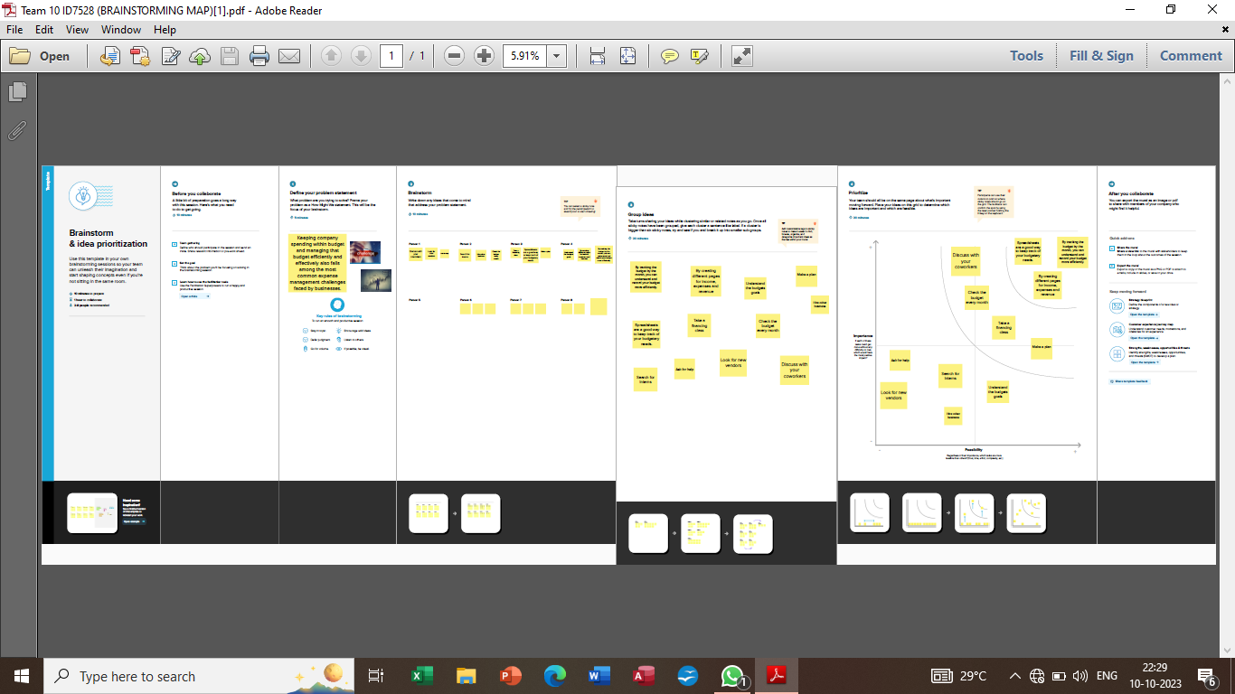

* Make a brainstorm map used in mural website, in brainstorm we discussed the define problem and understanding the problem.
* First we have defined what are the problems and types in the question box.
* Then it is a group idea and is write in the box person 1, person 2, person 3, person 4 now four person give different idea for problem.
* Take best three idea and type in the last box.

# RESULT

* Before opening the tableau desktop we had download the dataset for our project.
* After download the dataset we open the tableau desktop.
* After opening the option, selected connect to data, select the more option and select the dataset.
* After finishing the analysis data, add a dashboard.
* We created a story in the tableau desktop.

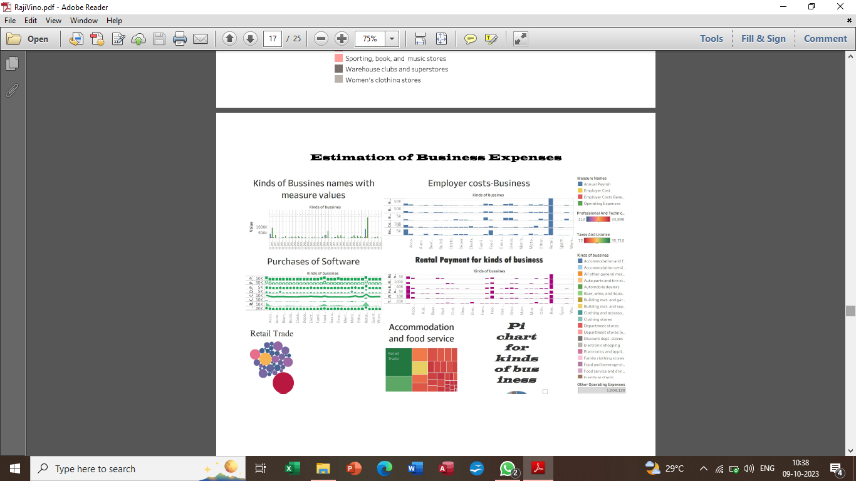

# ADVANTAGES & DISADVANTAGES

Advantages

* Tableau can handle millions of rows of data with ease. Different types of visualization can be created with a large amount of data without impacting the performance of the dashboards. Also, there is an option in Tableau where the user can make “live” to connections to different data sources like SQL etc.
* Some advantages of estimation of business expenses,
* Accurate planning.
* Cost estimation helps predict future expenses accurately.
* Increased profit margins.

Disadvantages

* Tableau does not provide the feature of automatic refreshing of the reports with the help of scheduling.
* Tableau is not a complete open tool.
* It can be expensive to implement and it is time consuming.
* It is not flexible enough to answer what if questions.
* New estimates must be built for each alternative.

# APPLICATION

* Business Intelligence.
* Data Visualization.
* Data Collaboration.
* Data Blending.
* Real time data analysis.
* Query translation into visualization.
* To import large size of data.
* To create no code queries.
* A construction company may use cost estimation to determine the specific amount of materials and labour required for a new building profect.

# CONCLUSION

* The conclusion of value is an estimate of the value of a business, business ownership interest, security, or intangible asset, arrived at by applying the valuation procedures appropriate for a valuation engagement.

# FUTURE SCOPE

* The future of Tableau
* If a tool provides interactive dashboards and reports less time backed by accurate data, who wouldn’t try the tool? Thus, all businesses are adopting this tool and gaining actionable insights in quick time and making informed decisions.